SCIENCE UNIT PLAN
Planet Earth and Beyond - Levels One and Two – Three and Four
Term: Year: Class: Duration: Context / Topic:
NATURE OF SCIENCE ACHIEVEMENT OBJECTIVES - Levels 1 and 2 Students will:
Understanding about science  - Appreciate that scientists ask questions about our world that lead to investigations and that open-mindedness is important because there may be more than one explanation. |  | Investigating in science  - Extend their experiences and personal explanations of the natural world through exploration, play, asking questions, and discussing simple models. |  |  |  |  | Communicating in science  - Build their language and develop their understandings of the many ways the natural world can be represented. |  |  |  |  |  | Participating and Contributing  - Explore and act on issues and questions that link their science learning to their daily living.
Understanding about science  Level 3  - Appreciate that science is a way of explaining the world and that science knowledge changes over time.  - Identify ways in which scientists work together and provide evidence to support their ideas. |  | Investigating in science  Level 3  - Build on prior experiences, working together to share and examine their own and others’ knowledge.  - Ask questions, find evidence, explore simple models, and carry out appropriate investigations to develop simple explanations. |  |  |  |  | Communicating in science  Level 4  - Begin to use a range of scientific symbols, conventions, and vocabulary.  - Engage with a range of science texts and begin to question the purposes for which these texts are constructed. |  |  |  |  |  | Participating and Contributing  Level 4  - Use their growing science knowledge when considering issues of concern to them.  - Explore various aspects of an issue and make decisions about possible actions.
PLANET EARTH AND BEYOND ACHIEVEMENT OBJECTIVES – Levels 1 and 2 Students will:
Earth Systems
- Explore and describe natural features and resources.
Interacting Systems
- Describe how natural features are changed and resources affected by natural events and human actions.
Astronomical Systems
- Share ideas and observations about the Sun and the Moon and their physical effects on the heat and light available to Earth.
PLANET EARTH AND BEYOND ACHIEVEMENT OBJECTIVES – Level 3
Students will:
Earth Systems
- Appreciate that water, air, rocks and soil, and life forms make up our planet and recognise that these are also Earth’s resources.
Interacting Systems
- Investigate the water cycle and its effect on climate, landforms, and life.
Astronomical Systems
- Investigate the components of the solar system, developing an appreciation of the distances between them.
PLANET EARTH AND BEYOND ACHIEVEMENT OBJECTIVES – Level 4
Students will:
Earth Systems
- Develop an understanding that water, air, rocks and soil, and life forms make up our planet and recognise that these are also Earth’s resources.
Interacting Systems
- Investigate the water cycle and its effect on climate, landforms, and life.
Astronomical Systems
- Investigate the components of the solar system, developing an appreciation of the distance between them.
GLOBAL LEARNING INTENTIONS – Level 1 We are learning to:  Understand what the Solar System is |  |  |  |  |  |  |  | GLOBAL LEARNING INTENTIONS – Level 2 We are learning to:  Understand the differences between living on earth and in space
NOTES ABOUT ENTRY LEVEL OF STUDENTS (Prior Knowledge/Skills Required): |  |  |  |  |  |  |  | CAREERS:
VALUES | Excellence |  | ☻ | KEY COMPETENCIES |  | Thinking |  |  | ☻ | ASSESSMENT |  | Pre-test (Diagnostic)
VALUES | Innovation, enquiry and curiosity |  | ☻ |  |  | Using Language, Symbols and Texts |  |  | ☻ |  |  | Post-test (Summative)
VALUES | Diversity |  | ☻ |  |  | Managing Self |  |  | ☻ |  |  | Sample
VALUES | Equity |  | ☻ |  |  | Relating to Others |  |  | ☻ |  |  | Observation |  | ☻
VALUES | Community and Participation |  | ☻ |  |  | Participating and Contributing |  |  | ☻ |  |  | Self Assessment |  | ☻
VALUES | Ecological Sustainability |  |  |  |  |  |  |  |  |  |  | Peer Assessment |  | ☻
VALUES | Integrity |  |  |  |  |  |  |  |  |  |  | ARB’s
VALUES | Respect |  | ☻ |  |  |  |  |  |  |  |  | Other e.g. Exemplars, asTTle, etc
E-LEARNING (ICT) | Computer/Word Processing |  |  | OTHER CURRICULUM LINKS |  | English |  |  |  | GAPS TO COVER |  | Literacy Gaps:  Numeracy Gaps:  Other Gaps:
E-LEARNING (ICT) | Publisher/Excel/PowerPoint |  | ☻ |  |  | Mathematics and Statistics
E-LEARNING (ICT) | e-mail/Fax/Phone/Scan |  |  |  |  | Science |  |  | ☻
E-LEARNING (ICT) | Internet-Research |  | ☻ |  |  | Social Sciences |  |  | ☻
E-LEARNING (ICT) | Digital Camera/Video |  |  |  |  | Technology |  |  | ☻
E-LEARNING (ICT) | Internet – Webquests and Web 2.0 |  |  |  |  | The Arts (Music/Dance/Drama/Visual) |  |  | ☻
E-LEARNING (ICT) | Video Conferencing |  |  |  |  | Health and Physical Education |  |  | ☻
E-LEARNING (ICT) | Inspiration and Other Programmes |  | ☻ |  |  | Learning Languages (Te Reo etc)
E-LEARNING (ICT) | Programming |  |  |  |  | EOTC
SPECIFIC LEARNING INTENTIONS  We are learning to:  (What should the students learn?  What do I intend them to learn?)  SUCCESS CRITERIA  We know we have achieved this when we can:  (How will the students know they have achieved?  Specific ideas on which to base teaching and activities) |  |  |  | ACTIVITIES, THINKING TOOLS AND OTHER RESOURCES  (What will I do to help my students achieve this?  Strategies/activities linked to Key Competencies to help students achieve)
SPECIFIC LEARNING INTENTION/S:  Where is space, who goes there and how  SUCCESS CRITERIA:  Children can describe where space is and how to get there |  |  |  | 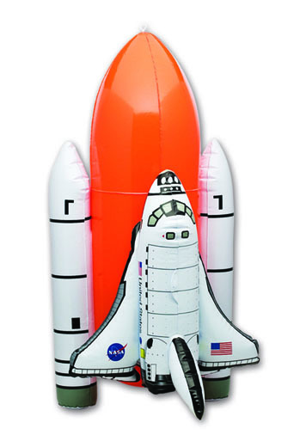    Question children on prior knowledge about space and planets  Introduce space models – demonstrate  Rocket – single component that separates as it goes into space e.g. Moon Missions  Space Shuttle – 4 components’ that separate on the way into space  Countdown by children – maths – 10 9 8 7 6 5 4 3 2 1 blast off!  Child volunteer holds earth globe – lesson explains gravity and how it affects the spacecraft after it has left earth.  Orbiting and where the sun is  90 minutes to orbit the earth
SPECIFIC LEARNING INTENTION/S:  Compare space clothing to daily living clothes  SUCCESS CRITERIA:  Children try on Astronaut Flight Suits |  |  |  | Invite children to try on Astronaut Flight Suits.  Demonstrate how to put them on and why/how the Astronauts use them  - For training in  - Wearing on spacecraft  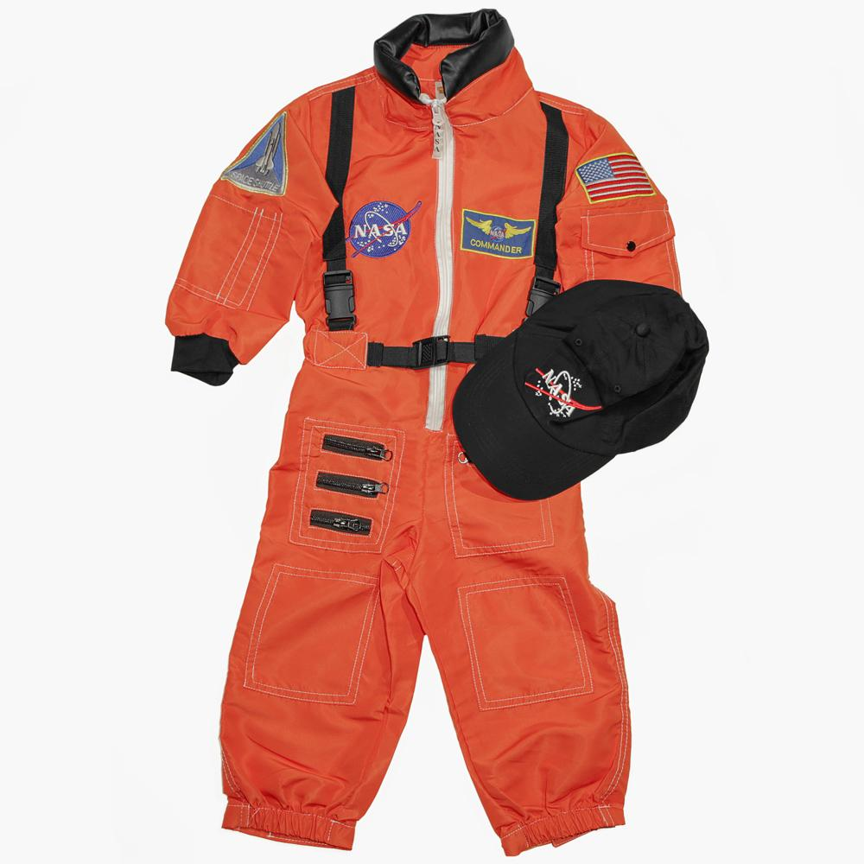  - Difference between flight suit and space suit
SPECIFIC LEARNING INTENTION/S:  How spacecraft launch into space. Propulsion systems  SUCCESS CRITERIA:  Children can describe how to get into space |  |  |  |   Movie – Dream is Alive  Stop video in places and talk about what is happening  Assessment – question children
SPECIFIC LEARNING INTENTION/S:  How astronauts eat, live and work in Space  SUCCESS CRITERIA:  Children can explain how Gravity affects living in Space |  |  |  | Power Point Slides  Movie – Astro Smiles  Point out learning points – floating astronauts and food, containing food  How to go to the toilet in space
SPECIFIC LEARNING INTENTION/S:  Children learn the difference between space food and earth food  SUCCESS CRITERIA:  Children can explain how space food is prepared for flight and the difference from earth food |  |  |  | 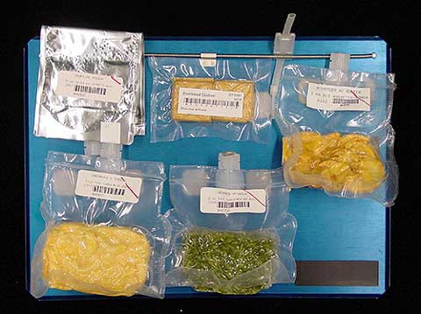  NASA Space Food samples shown and demonstrated  Explaining dehydration/thermo stabilised food  Food cooked prior to being put on board spacecraft  Food has to be light to save weight on spacecraft into space  Lifting ability of the rockets is limited by weight restrictions
SPECIFIC LEARNING INTENTION/S:  We are learning to make an Astronaut bookmarks/puppet  SUCCESS CRITERIA:  Children create their own Astronaut bookmark and can use it in a book |  |  |  | EDIP – Explain, Demonstrate, Imitate, making an Astronaut bookmark  Colouring in (hand eye co-ordination – staying in the lines)  Cutting out –training hand and fingers for dexterity and agility using scissors  Taping sticks to shape  Schools optional to provide photo of children. Children trace around template and cut out their faces to glue into helmet    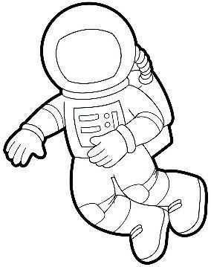  Children use bookmark and/or develop puppet plays using their shapes
SPECIFIC LEARNING INTENTION/S:  We are learning to make a Planet Plate  SUCCESS CRITERIA:  Children can name the planets and in order from the sun |  |  |  | EDIP – Explain, Demonstrate, Imitate, making a planet plate/Star mobile  Colouring in (hand eye co-ordination – staying in the lines)  Cutting out –training hand and fingers for dexterity and agility using scissors  Glue stick – children stick planets on their paper plate  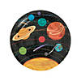    My Very Educated Mother Just Served Us Nachos
SPECIFIC LEARNING INTENTION/S:  We are learning to make a Solar System Hat  SUCCESS CRITERIA:  Children make and wear a planet head dress |  |  |  | 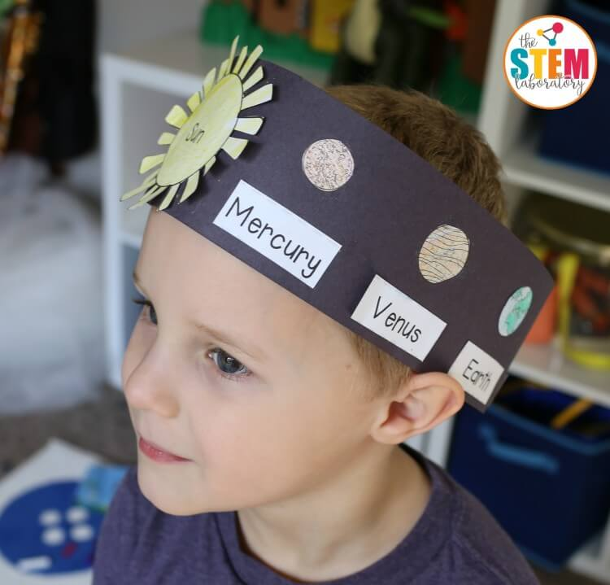  EDIP – Explain, Demonstrate, Imitate, making a solar system hat  Colouring in planets (hand eye co-ordination – staying in the lines)  Cutting out –training hand and fingers for dexterity and agility using scissors  Glue stick – children stick planets on strips to wear around their heads
SPECIFIC LEARNING INTENTION/S:  We are learning about space clothing  SUCCESS CRITERIA:  Children can identify different parts of a space suit |  |  |  | 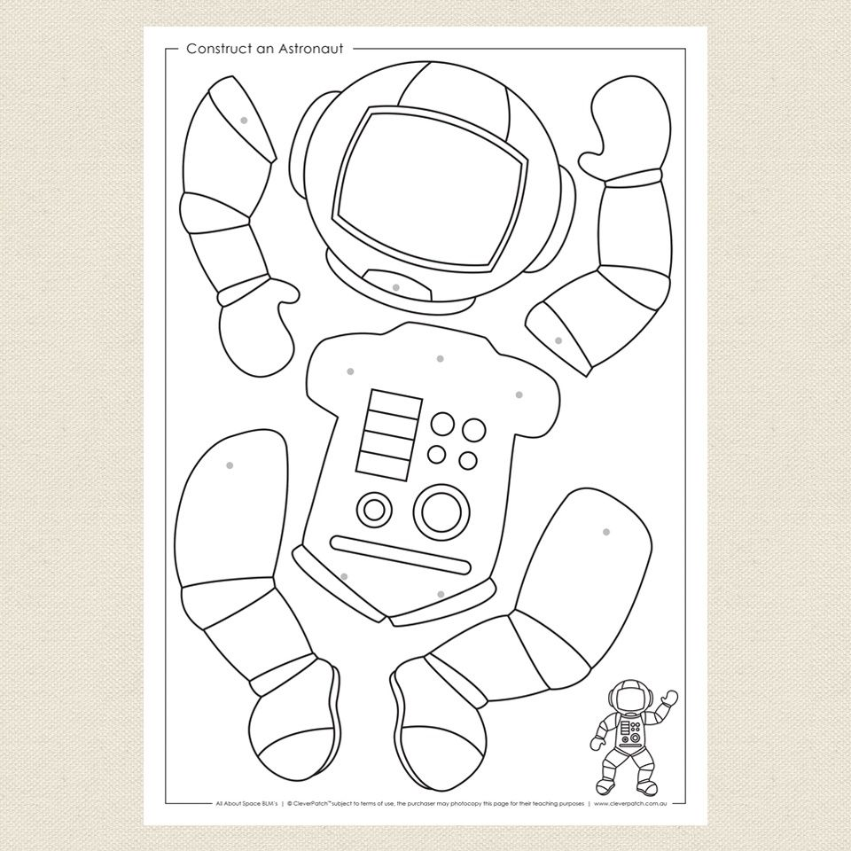  EDIP – Explain, Demonstrate, Imitate, making an Astronaut puppet  Colouring in (hand eye co-ordination – staying in the lines)  Cutting out –training hand and fingers for dexterity and agility using scissors  Using blue tack and a pen to push holes into the parts of the puppet  Attaching arms and legs with push pins
SPECIFIC LEARNING INTENTION/S:  We are learning about Mars Rover “Perseverance” and Helicopter “Ingenuity”  SUCCESS CRITERIA:  Children can make and fly Mars Helicopter “Ingenuity” |  |  |  | 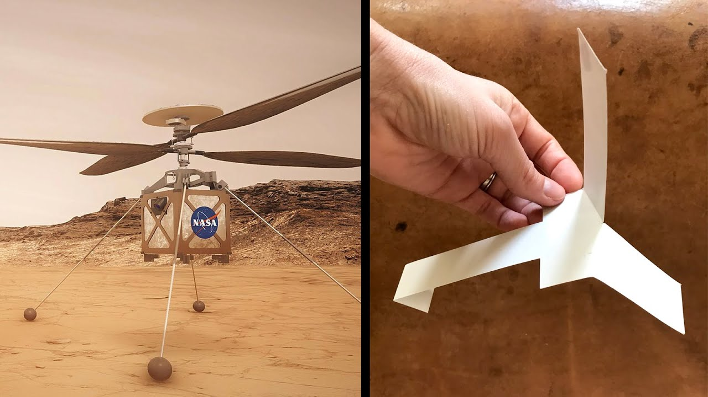  EDIP – Explain, Demonstrate, Imitate, making a Mars Helicopter  Appreciate that scientists ask questions about our world that lead to investigations and that open-mindedness is important because there may be more than one explanation. Relate this to Mars exploration of finding life on other planets and why humans are doing this. Children make and fly a Mars Helicopter learning about principles of flight and thin Martian Atmosphere so extra blades on the helicopter.
SPECIFIC LEARNING INTENTION/S:  Build and fly a space shuttle glider  SUCCESS CRITERIA:  Children can fly their space shuttle glider |  |  |  | 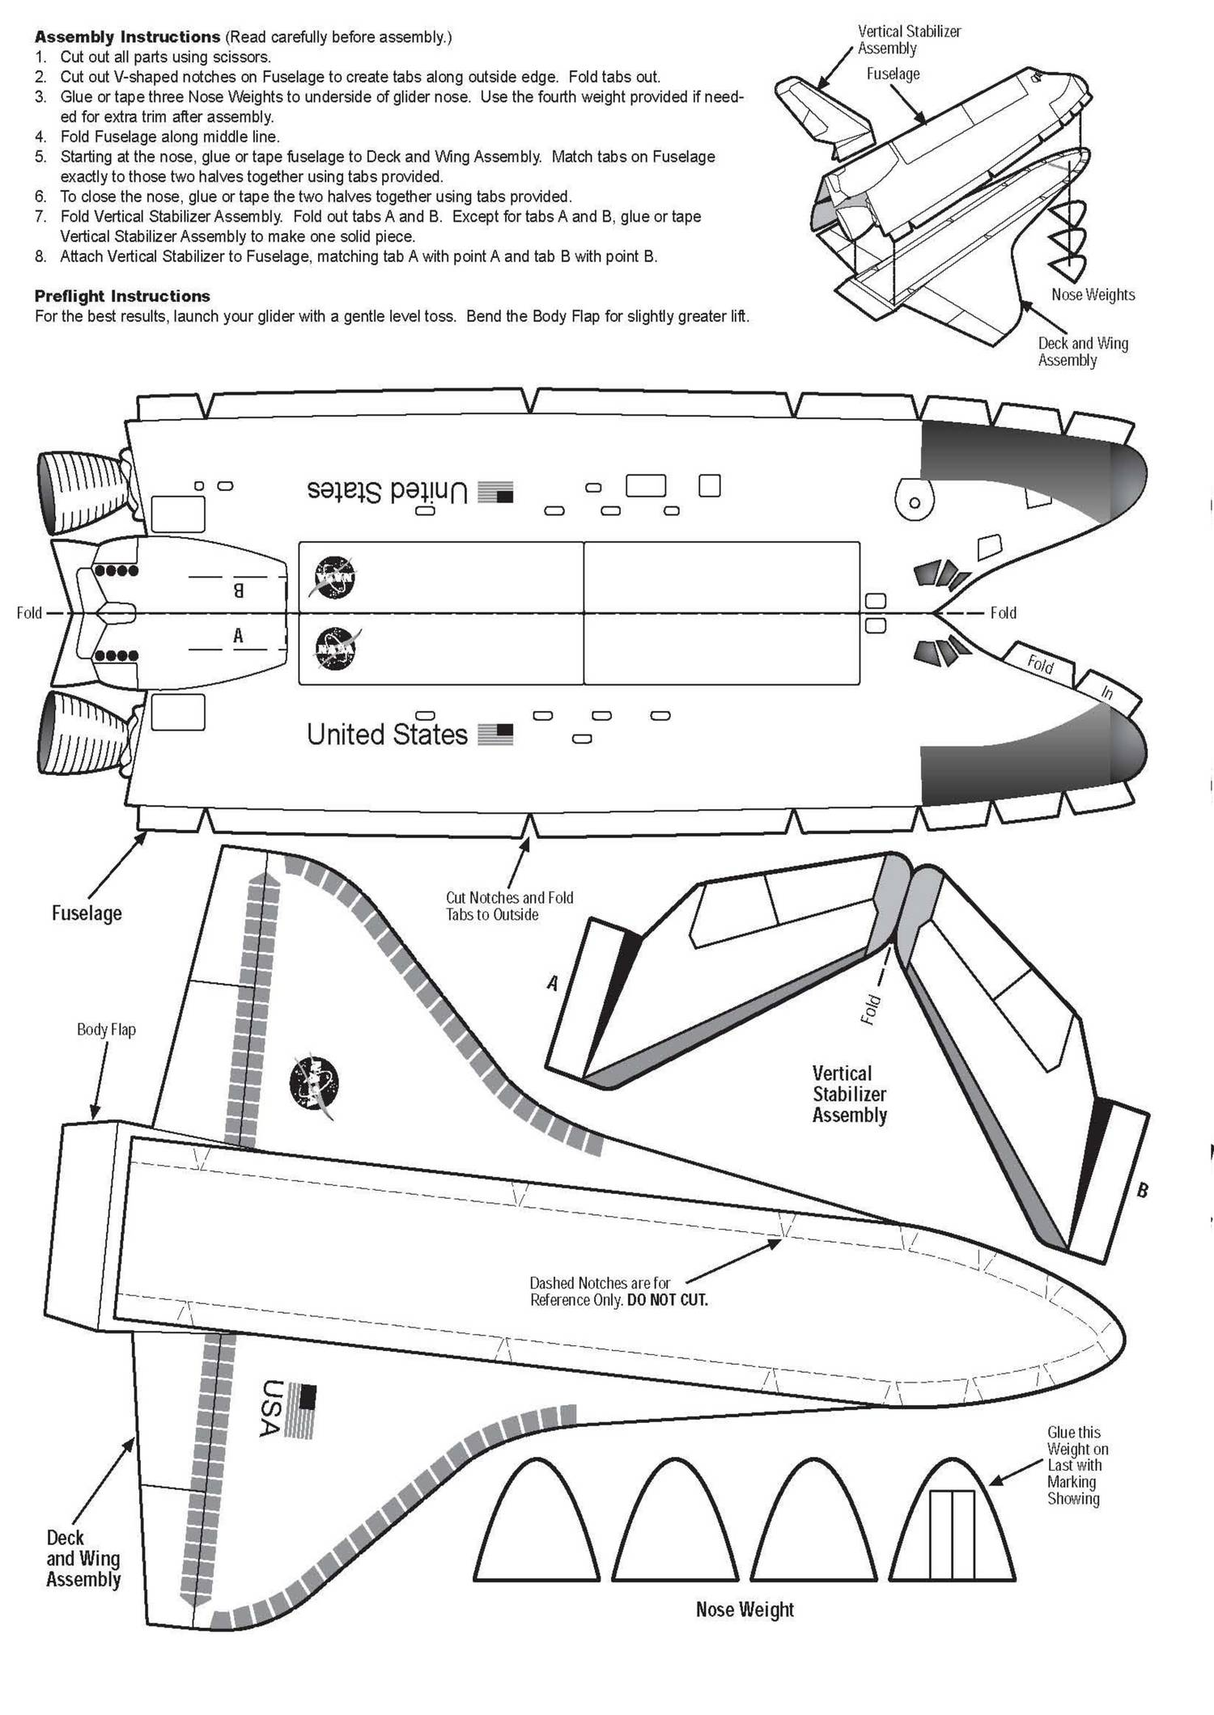  EDIP – Explain, Demonstrate, Imitate, making a Space Shuttle Glider  Colouring in (hand eye co-ordination – staying in the lines)  Cutting out –training hand and fingers for dexterity and agility using scissors  Understanding instructions on how to put the glider together  Use tape to join the parts
SPECIFIC LEARNING INTENTION/S:  Learning about space craft propulsion systems  SUCCESS CRITERIA:  Children build and safely launch their paper rocket |  |  |  | 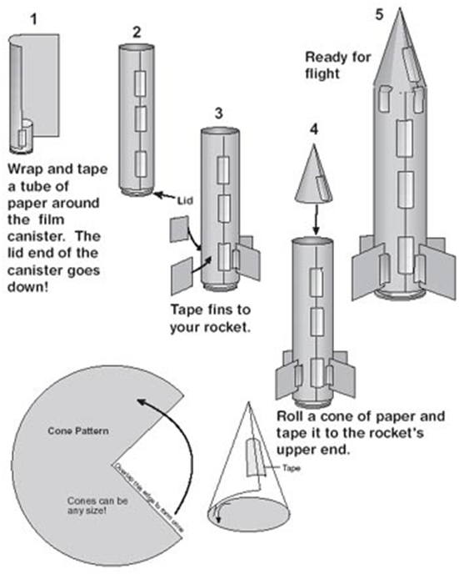  Using Language, Symbols and Texts  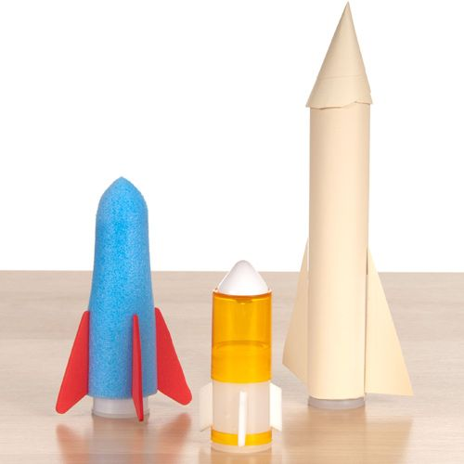  Children follow/understanding instructions  Folding and cutting paper  Use tape to join the parts  Wear safety glasses to appreciate safety when  launching rockets  Aspro clear tablets inside film canisters activated with water  Creating bubbling solution that expands to pop off the cap  and launch paper rocket
SPECIFIC LEARNING INTENTION/S:  Learning about space craft propulsion systems  SUCCESS CRITERIA:  Children build and safely launch their paper rocket |  |  |  | Investigating in science  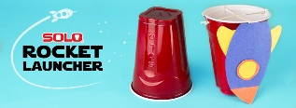  Extend their experiences and personal explanations of the natural world through exploration, play, asking questions, and discussing simple models.  Thinking, managing self, participating  Using the paper cup rocket model children can colour in and cut out their rocket, then tape it to the cup.  Teacher models how to insert the cup into another the let  go propelling the rocket cup into the air. Have children write their name on the cups.
SPECIFIC LEARNING INTENTION/S:  Learning about phases of the moon  SUCCESS CRITERIA:  Children understand phases of the moon and make a moon cootie |  |  |  | 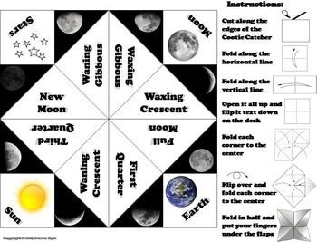  Using Language, Symbols and Texts show the various stages of the moon – youtube.  Children practice saying the moon phases.  Explain what a moon cootie is and show them a finished one.  EDIP – Explain, Demonstrate, Imitate, making a moon cootie
SPECIFIC LEARNING INTENTION/S:  Students are learning facts about the planets  SUCCESS CRITERIA:  Children can sort facts about planets through research |  |  |  | 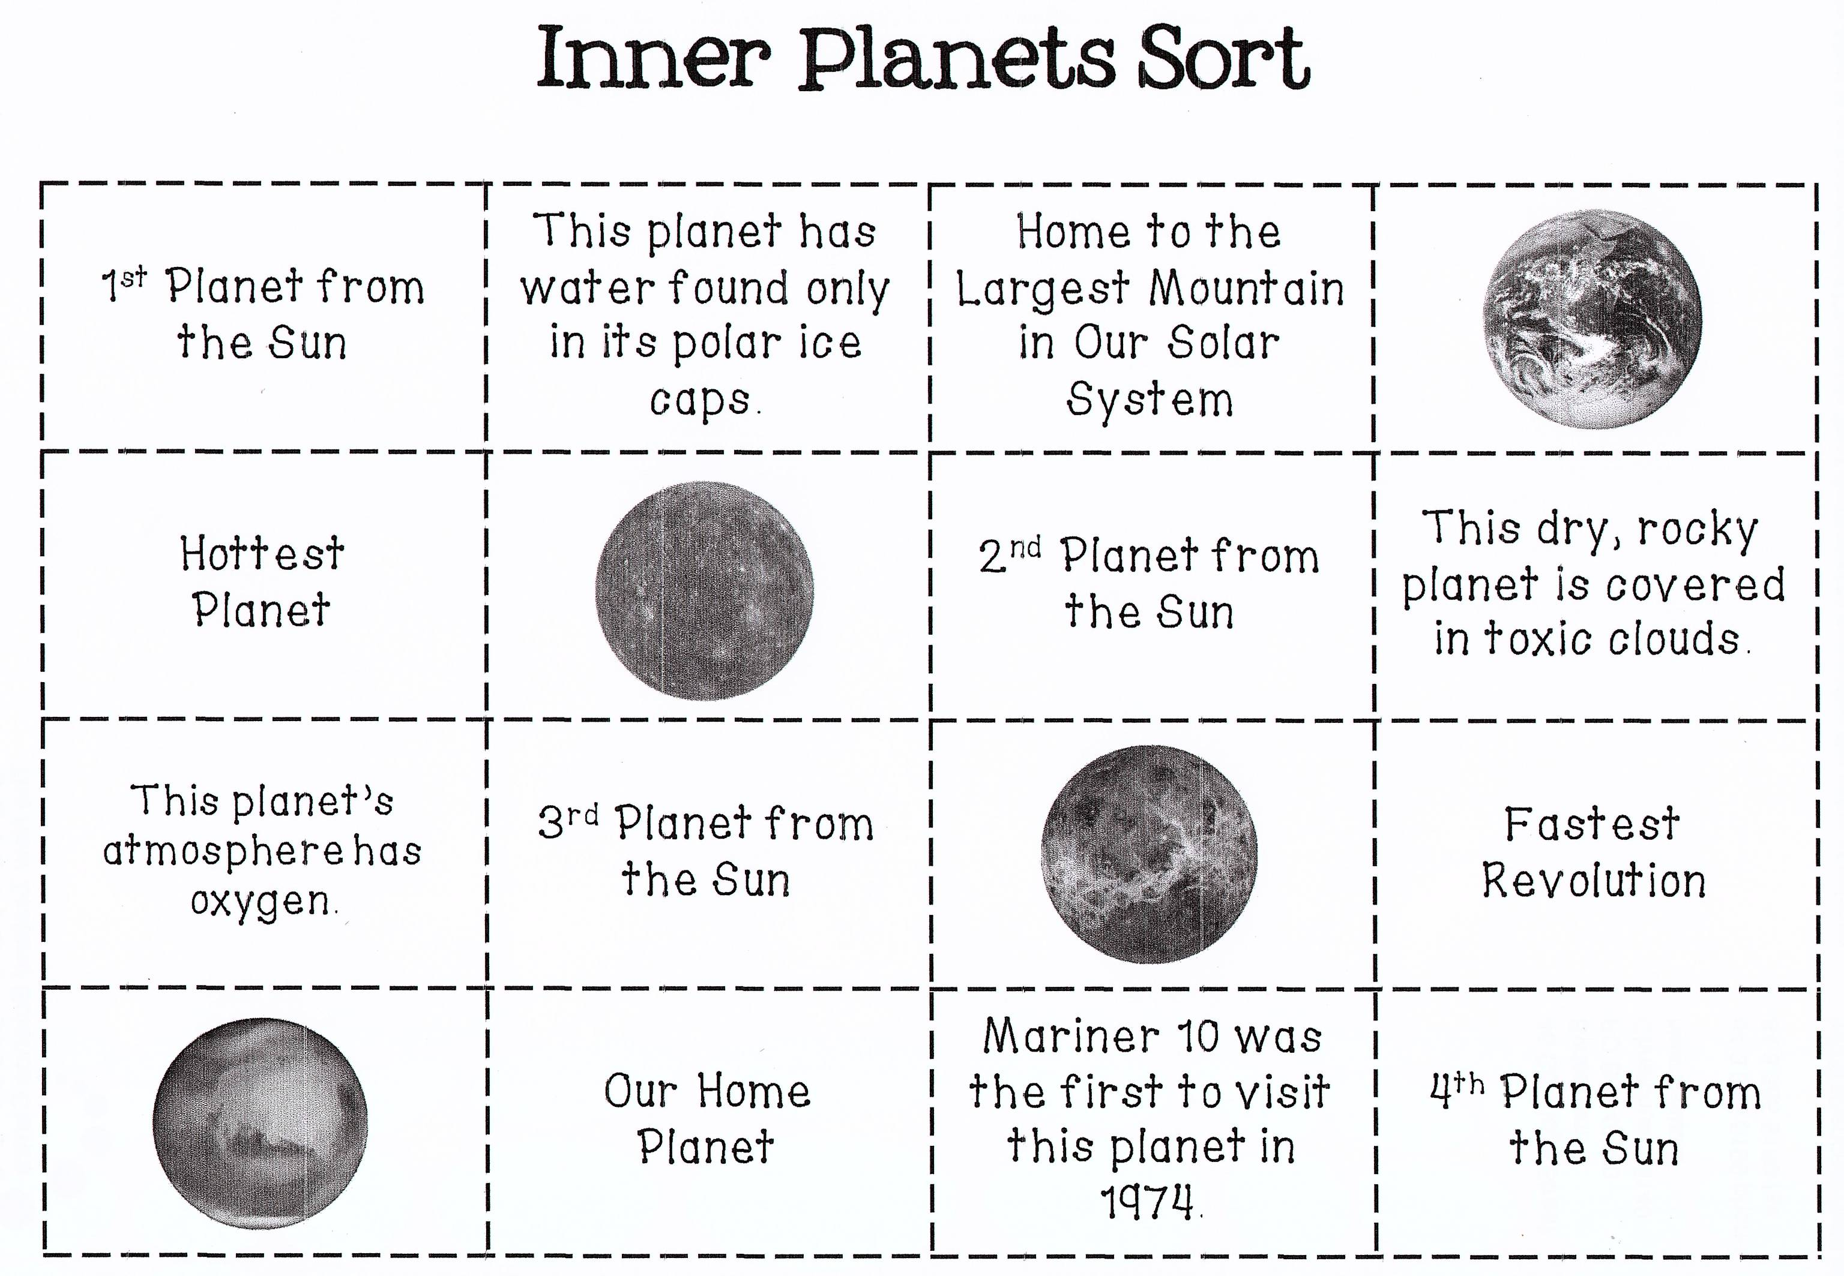  E-learning – internet research – children require access to IT  Devices  Teacher lead YouTube research about planets  Planet songs  Worksheets handed out for children to research on their own  and cut/paste correct facts to correct planets
SPECIFIC LEARNING INTENTION/S:  To re-enforce left & right as well as create and follow algorithms.  SUCCESS CRITERIA:  Children programme Bee Bots to move in different directions and can describe the direction. |  |  |  | Digital Technologies Processes and Production Skills Follow, describe and represent a sequence of steps and decisions (algorithms) needed to solve simple problems  Maths: Describe position and movement  EDIP – how Bee Bots work  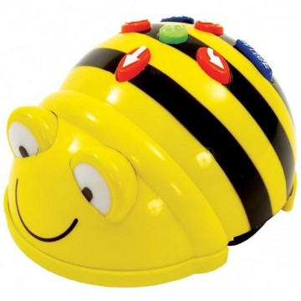  Children working in pairs learn to programme Bee Bots
GROUPS – CATERING FOR A RANGE OF INDIVIDUAL NEEDS AND ABILITIES
(based on diagnostic assessment prior to unit):
FORMATIVE NOTES
New Zealand Curriculum Review – UNDERSTAND, KNOW, DO
ASSESSMENT APPROACH
(How will I assess the Success Criteria? How can learning achievement be measured? Remember to include Formative Assessment)
BEFORE THE UNIT  Talk with classroom teacher/s to ask what  the children already know about earth and  space and if any lessons have been taught  prior.  Summative assessment |  |  |  |  | DURING THE UNIT  Observation assessment. Are children engaging with the lessons, asking questions, participating  Formative assessment  Peer assessment |  |  |  |  |  | AFTER THE UNIT  Assessment survey of presentation teacher
UNIT EVALUATION
(Consider: Planning and preparation; catering to individual students’ needs; challenging all students; use of class time; overall delivery;
success of unit based on assessment and anecdotal observations; areas for future improvement – what would have worked better)
CHILDREN’S LEARNING |  |  |  |  | PERSONAL TEACHINGS |  |  |  |  |  | ASSESSMENT FOR FUTURE PLANNING  For these students:  For teaching students in the future:

